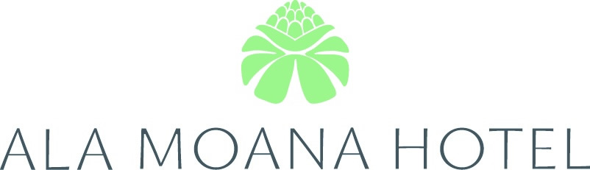
410 Atkinson Drive, Honolulu, HI 96814

GROUP NAME: AAMAS
Group name must be specified when
making your reservation.
DATES: May 14-18, 2007

SPECIAL GROUP ROOM RATES
(ROOM RATES ARE PER NIGHT)

CATEGORY | SINGLE | DOUBLE | TRIPLE
*Kona Tower | $99 | $99 | $139
**Waikiki Tower | $129 | $129 | $169
*Queen Bed **Choice of King or Two Double Beds/ room No Rollaways Allowed
Room rates are subject to General Excise Tax of 4.712% plus Transient Accommodations Tax of 7.25%. (Subject to change.)

Reservation form must be received by the hotel by April 13, 2007. Reservations received after April 13, 2007 are subject to room availability. Room requests for extended dates will be confirmed on space availability basis only, if confirmed, will be done at the group rate.

Major credit card information must accompany the reservation request to guarantee the room. Reservations can also be made by phone by calling toll-free (800) 367-6025 (U.S. & Canada), (800) 446-8990 (Neighbor Islands), direct (808) 955-4811/Group Reservations, or by facsimile (808) 944-6839. For more hotel information, go to www.alamoanahotel.com.

Cancellations received within 72 hours of arrival will be charged one night’s room rate plus taxes.

Adjacent room requests will be confirmed subject to availability only. No charge for children under 18 years of age when occupying room with full paying adult and utilizing existing bedding. Ala Moana Hotel is a non-smoking hotel.

Hotel check-in time is 3:00 PM. Check-out time is 12:00 noon.

DETACH AND MAIL
(1) form per room

GROUP NAME: AAMAS
Group name must be specified when
making your reservation.
DATES: May 14-18, 2007

PLEASE PRINT:
NAME:
ADDRESS:
ARRIVAL DATE: |  |  |  |  |  |  |  |  | TIME: |  |  |  | DEPARTURE DATE: |  |  |  |  |  |  |  |  |  |  |  |  | TIME:
PHONE: |  |  |  |  |  |  |  |  |  |  |  |  |  | FAX:
CATEGORY SELECTED: |  |  |  |  |  |  |  |  |  | SGL |  |  |  |  | DBL |  |  |  |  |  |  |  |  | TPL |  |  | RATE:
SHARING ROOM WITH: |  |  |  |  |  |  |  |  |  |  |  |  |  |  |  |  |  |  |  |  | *ALA MOANA HOTEL IS A NON-SMOKING HOTEL*
CREDIT CARD: |  |  |  | AMEX MC VISA CARTE BLANCHE/ DINERS JCB
ACCOUNT NUMBER: |  |  |  |  |  |  |  |  |  |  |  |  |  |  | EXP. DATE:
CARDHOLDER’S NAME:
 |  |  |  |  |  |  |  | (Please Print) |  |  |  |  |  |  |  |  |  |  |  | (Signature)

Credit card guarantee must be included with this form.

