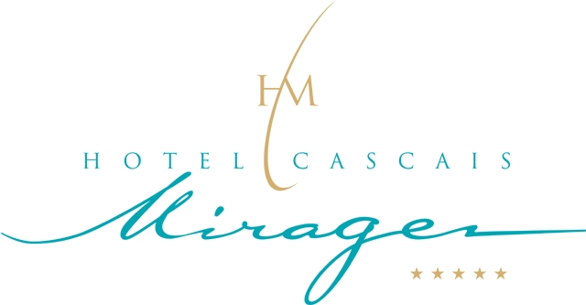

AAMAS Congress – 12/16 May 2008

ACCOMMODATION BOOKING FORM
Please FAX, POST or Email this booking form to the hotel.

Hotel Cascais Miragem, Av. Marginal Nº8554, 2754-536 Cascais, Portugal
Ph: + 351 210 060 600 / Fax: +351 210 060 601
Email: reservations@cascaismirage.com

Guest Name: ______________________________ Title: _______ Initials: ________

Address: ________________________________________________________________

Telephone: ______________________ Fax: ______________________

Email: __________________________________

Company Name: _________________________________ Expected Time of Arrival: _____

Telephone: ______________________ Fax: ______________________

Date of Arrival: ___ / ___ / ___ No. of Nights: ________ Type of Room: ________

Hotel: | Single or Double, without balcony and sea view (breakfast not included) | Single or Double, with balcony and sea view (breakfast not included)
Hotel Cascais Miragem | € 160 | € 190
Breakfast: 20 euros per person.
The rates are per room, per night, all services and taxes. Breakfast not included
This rate will apply for rooms booked 5 days prior through 5 days after the meeting dates.

Payment Details:

Card Type: Visa / Amex / Diners / Master / Other ____________________________________

Card No.: __________________________________ Expiry Date: ____ / ____ CVV: ______

*** PLEASE NOTE ***

THE FINAL CUT-OFF DATE FOR BOOKING IS THE March, 8th, 2008.

FOLLOWING THIS DATE ALL BOOKINGS WILL BE SUBJECT TO AVAILABILITY
Reservations must be made using this form in order to avail of this special conference rate.

In the event of cancellation and avoiding cancellation charges
Please cancel accommodation directly with hotel and acquire a cancellation number.
Cancellations will only be accepted two weeks before the arrival day.
No Shows will be charge on the basis of the entire reservation o each individual participant.

Special Requests: ________________________________________________________

Signed: _______________________________ Date: ____ / ____ / ____

